Data Analysis of 2013 New York City Flights
Lindsay Gross, Siyu Li, Bryan Alfonso Llobrera
Math 151: Fundamentals of Data Science
May 6, 2026

Background
This project uses the NYC flights dataset from 2013, which contains 336,776 observations and 19 variables related to flight operations in New York City.
Initial inspection shows that several variables, including dep_time, dep_delay, arr_time, arr_delay, tailnum, and air_time, contain missing values. To ensure meaningful analysis, observations with missing values in departure delay and arrival delay were removed. After this filtering step, the remaining dataset contains no missing values across all variables, as these missing values are primarily associated with cancelled or incomplete flights.
After cleaning, approximately 97.2% of the original data was retained, indicating that the proportion of missing data is relatively small and unlikely to significantly affect the analysis. The cleaned dataset contains 327,346 observations with no missing values across all variables.
The dataset includes several numerical variables, each describing specific aspects of flight operations:
year, month, day: calendar date of the flight
dep_time: actual departure time
sched_dep_time: scheduled departure time
dep_delay: departure delay (in minutes)
arr_time: actual arrival time
sched_arr_time: scheduled arrival time
arr_delay: arrival delay (in minutes)
air_time: time spent in the air (in minutes)
distance: flight distance (in miles)
hour: scheduled departure hour
minute: scheduled departure minute
flight: flight number (identifier)
The dataset also includes several categorical variables: carrier, tailnum, origin, dest, and time_hour. These variables describe airline carrier, aircraft tail number, departure airport, destination airport, and flight time information.
This combination of numerical and categorical variables provides a rich source for analyzing flight delay patterns from multiple perspectives. Flight delays are a common issue in air transportation systems and can be influenced by various operational and environmental factors. Understanding these patterns is important for improving airline performance and passenger experience. The goal of this study is to explore the factors that influence arrival delay and to build a multiple regression model to predict it. To achieve this, arrival delay (arr_delay) is treated as the response variable, as it represents the outcome we aim to explain and predict.

Univariate Analyses
To understand the behavior of flight delays, we first examine individual variables through univariate analysis. This includes analyzing distributions of numerical variables and comparing delay patterns across categorical variables. These analyses provide insights into delay characteristics and help guide subsequent modeling.

# Q1: What is the distribution of Arrival delays?
The distribution of arrival delay is clearly right-skewed.
The boxplot also shows that arrival delay is right-skewed. The median is -5 below 0, suggesting that a typical flight arrives slightly early. The middle 50% of flights fall between approximately -17 and 14 minutes, but many large positive outliers indicate that some flights experience severe arrival delays.
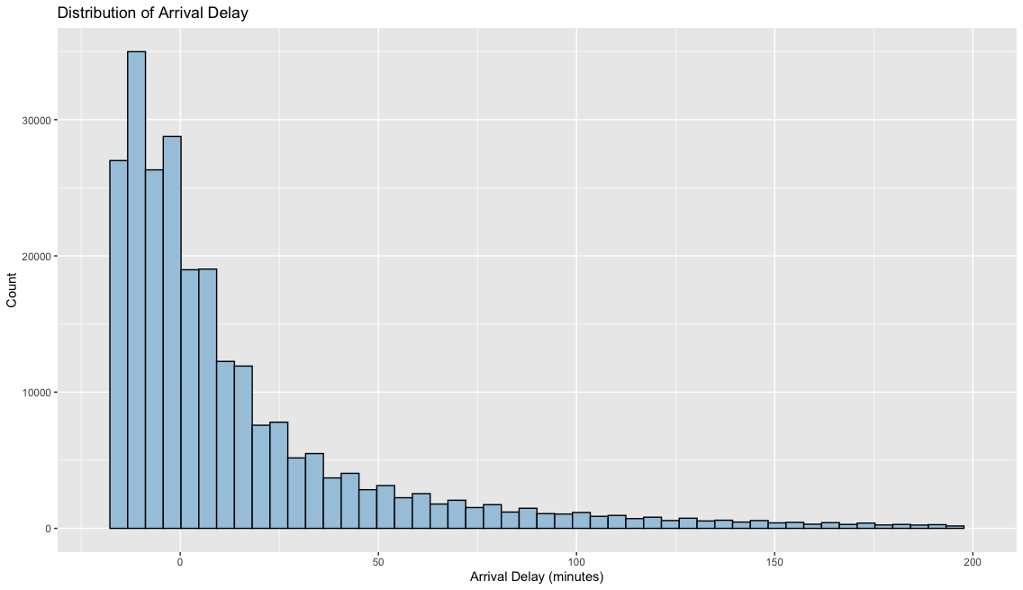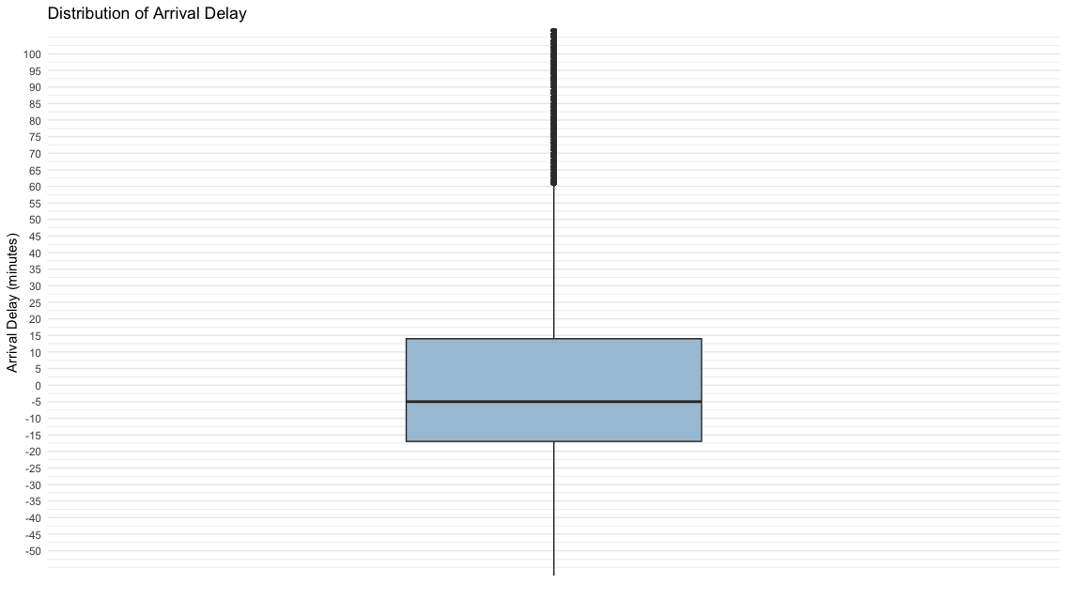
The summary statistics support this pattern: the median is approximately -5 minutes, indicating that many flights arrive on time or early, while the mean is about 6.9 minutes, reflecting the influence of large delays. This difference between the mean and median confirms the skewness of the distribution.
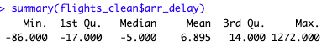

# Q2: What is the distribution of departure delays, and how is it related to arrival delays?
The distribution of departure delay is similar to that of arrival delay and is clearly right-skewed. Most flights experience small delays, while a small number of flights have extremely large delays, resulting in a long right tail. This is also supported by summary statistics, where the mean exceeds the median. Compared to arrival delay, departure delay exhibits a smaller spread, indicating that departure times are more consistent, while arrival delays show greater variability.
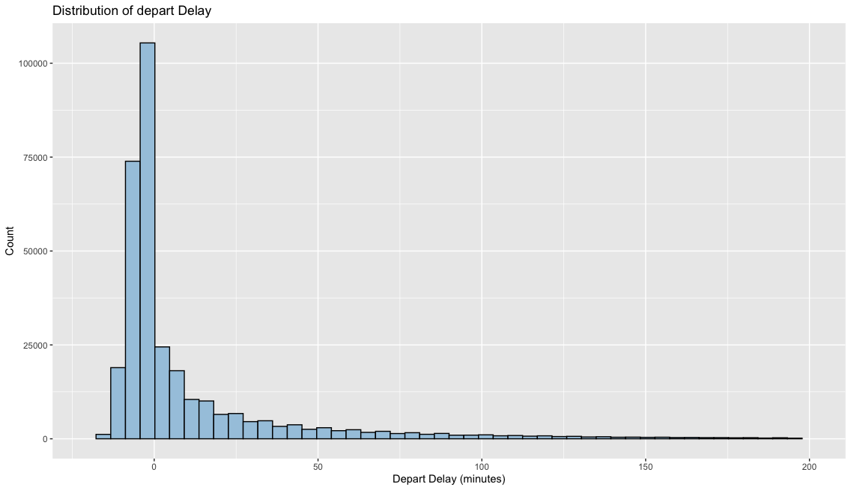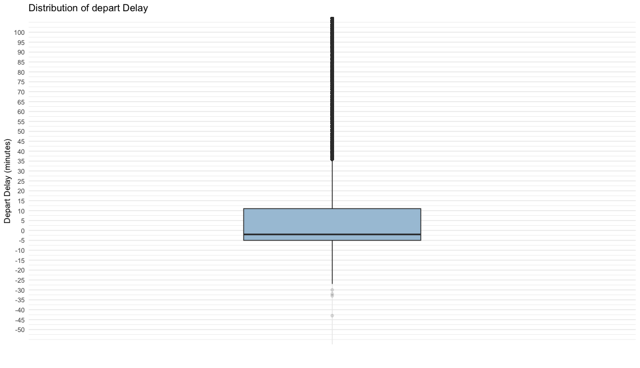
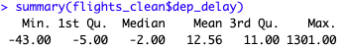

Bivariate Analyses
# Q3. Is there any relationship between departure delay and arrival delay?
To further investigate delay behavior, the relationship between departure delay and arrival delay is examined. The scatter plot shows a strong positive linear relationship, with a correlation coefficient of approximately 0.91. This indicates that flights that depart late are very likely to arrive late, suggesting that delays tend to propagate. This strong linear relationship suggests that departure delay should be included as a key explanatory variable in regression modeling.
However, some observations lie below the diagonal trend, indicating that certain flights are able to partially recover delays during the flight. This suggests that, in addition to departure delay, there may be other factors that influence arrival delay.
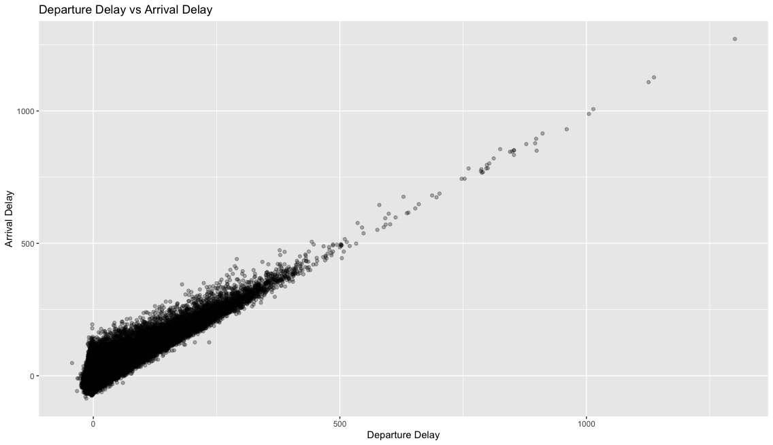
The ECDF plots provide additional insight into the distribution. Most flights experience relatively small delays. Approximately 60% of flights have little to no delay, while about 80%–85% fall within a relatively short delay range (15–30 minutes). The steeper ECDF curve for departure delay indicates that delays are more concentrated, whereas the flatter curve for arrival delay suggests greater variability.
Overall, delays are generally small but highly skewed, and departure delay appears to be a key factor influencing arrival delay.
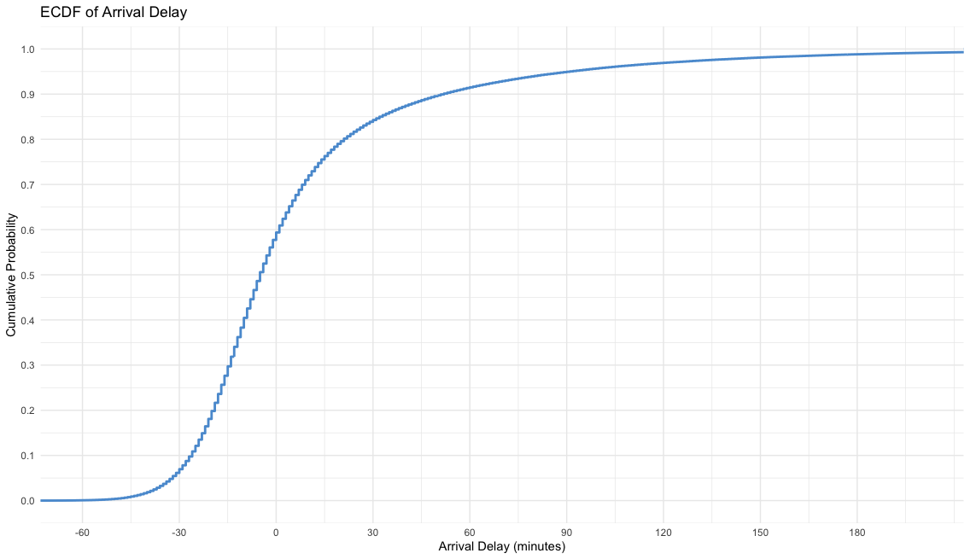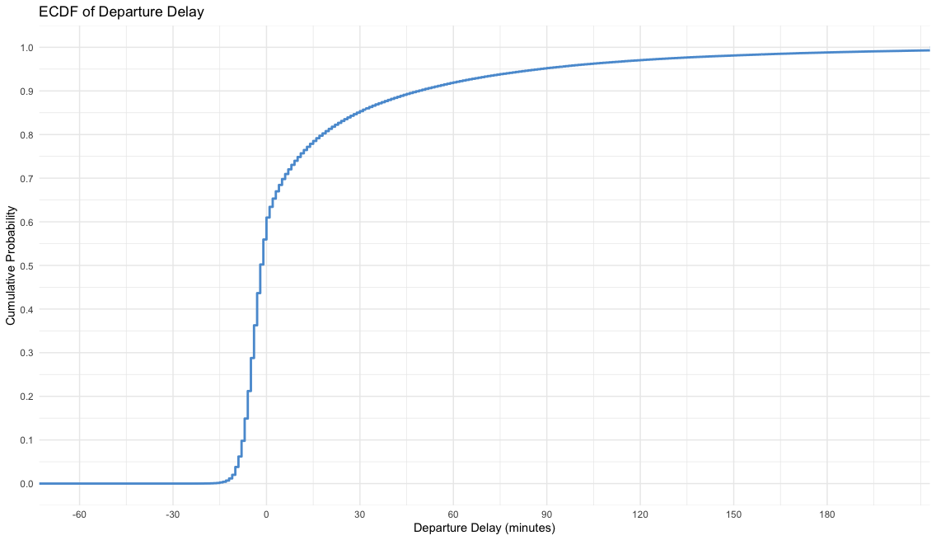

We next explore how delays vary across other different categorical variables. In particular, we focus on meaningful categorical features such as airline carrier, origin airport, and destination airport, as these variables may capture systematic differences in delay patterns.
Variables such as tail number are excluded from the analysis, as they serve only as identifiers and do not provide meaningful insight. The dataset includes three origin airports (EWR, LGA, and JFK), 105 destination airports, and 16 airline carriers, providing a rich set of categories for comparison.
We begin by addressing the question:

Q4a. Which origin airports have the highest average delays?
To examine how delays vary across origin airports, we compare the average departure delays for the three major airports: EWR, JFK, and LGA. The results show that Newark (EWR) has the highest average departure delay at approximately 15 minutes, followed by JFK (about 12 minutes) and LaGuardia (LGA) (about 10 minutes). This suggests that flights departing from EWR tend to have higher average delays compared to the other two airports. Overall, while all three airports experience delays, the differences across origin airports are relatively moderate.
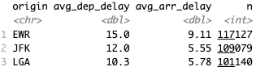
Q4b. Which destination airports have the highest average arrival delays?
To examine how delays vary across destination airports, we analyze average delays across all destinations, focusing on those with sufficient observations (n ≥ 500) to ensure reliable estimates.
The results show that some destinations, such as TYS and MSN, have particularly high average arrival delays exceeding 20 minutes In addition, many other destinations also exhibit relatively high delays, with average delays above 15 minutes.
Compared to origin airports, the variability in delays across destinations is substantially larger, indicating that delays differ more significantly by destination. This suggests that destination-related factors may play a more important role in influencing flight delays. Overall, destination airports show greater variation and appear to have a stronger impact on delay patterns than origin airports.
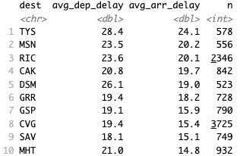
# Q5：Which airlines experience the highest average arrival delays?
The results show that average arrival delays and departure delays differ across airlines. Some carriers, such as F9 and EV, have relatively high average arrival delays, with average arrival delays exceeding 15 minutes. In contrast, other airlines, such as AS and HA, have much lower delays, with average arrival delays below 5 minutes
However, it is important to note that sample sizes differ substantially across airlines. For example, F9 has a relatively small number of observations, while EV has a much larger sample size. As a result, estimates for airlines with smaller sample sizes may be less reliable. Therefore, caution should be taken when comparing average delays across carriers, as differences in sample size may affect the comparability of the results.
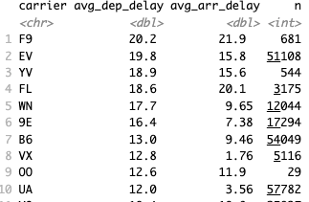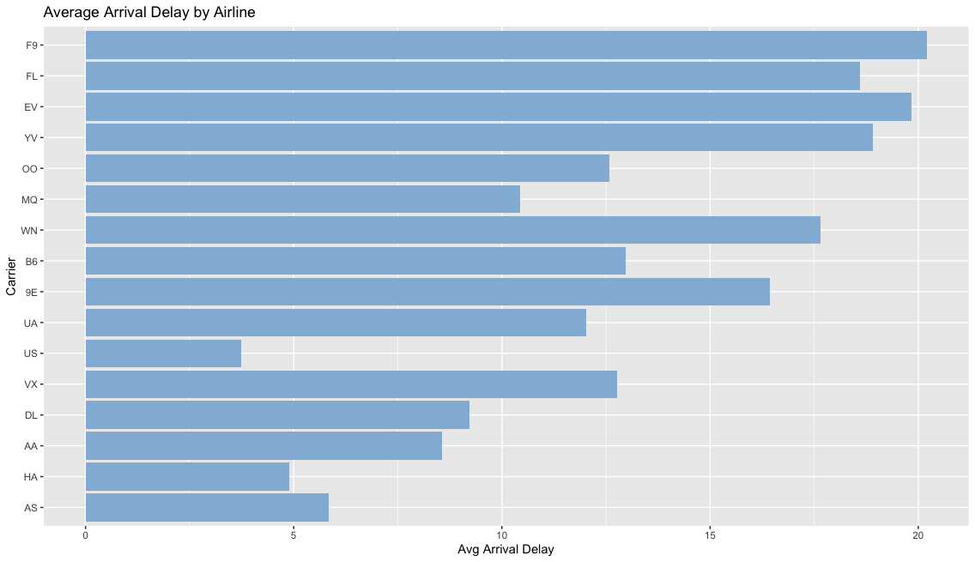
# Q6: How does arrival delay variability differ across categorical variables such as origin, carrier, and destination?
We also compare how delays vary across different categorical variables. We examine the range and dispersion of average delays for origin, carrier, and destination.
Delay variation is smallest across origin airports, with a range of about 4.7 minutes and standard deviation of 2.39. In comparison, variation is larger across carriers (range ≈ 16.5, SD ≈ 5.43) and greatest across destinations (range ≈ 43.9, SD ≈ 6.63). This indicates that delays differ much more across destinations and airlines than across origin airports.
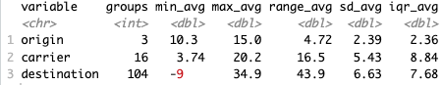

# Q7. How do delays vary across different times of the day?
Although hour is a numerical variable, it is treated as a categorical variable representing different time periods of the day.
To examine how delays vary across different times of the day, flights are grouped by scheduled departure hour, and the average arrival delay is computed for each time period. The results show a clear time-of-day pattern. Average arrival delays are lowest in the early morning(, with negative values indicating that flights tend to arrive earlier than scheduled. Delays then increase steadily throughout the day, becoming positive around mid-morning and continuing to rise into the afternoon. Arrival delays reach their peak in the evening, around 19:00–21:00, where average delays exceed 15 minutes. After this peak, delays begin to decline slightly later in the night.
This pattern suggests that delays accumulate over the course of the day. Early flights are less affected by prior disruptions, while later flights are more likely to experience cascading delays caused by earlier delays in the system.
Overall, time of day appears to be an important factor influencing arrival delay, with delays being minimal in the morning and most severe in the evening.
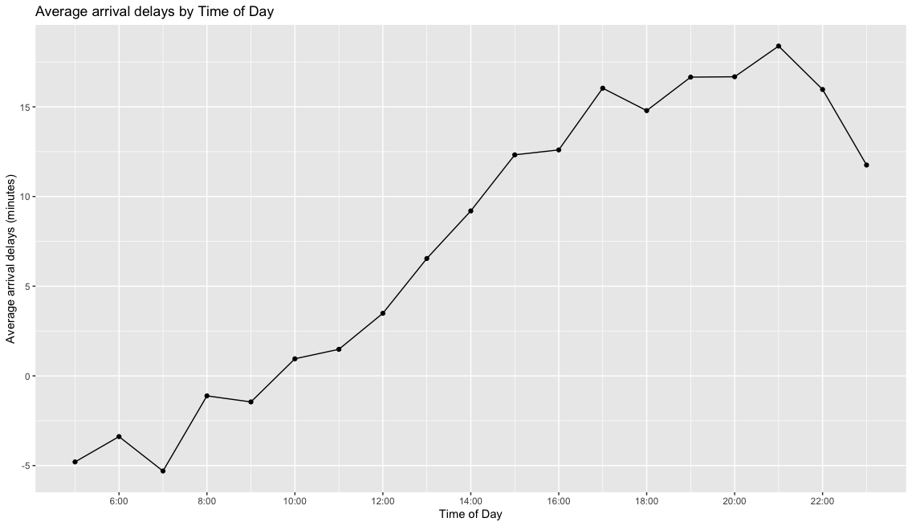
# Q8. How do arrival delays vary across seasons?
To examine how arrival delays vary across seasons, we treat season as a categorical variable and group flights into four seasons to compute average arrival delays. The results show clear seasonal differences. Summer has the highest average arrival delay (approximately 13.0 minutes), followed by Spring and Winter. In contrast, Fall has the lowest average arrival delay, with a slightly negative value (–1.22 minutes), indicating that flights tend to arrive early in that season. The sample sizes across seasons are relatively balanced (ranging from about 77,000 to 84,000 flights), suggesting that these comparisons are reliable.
Overall, these results indicate that delays are highest in summer and lowest in fall, suggesting that seasonal factors such as travel demand and weather conditions may influence arrival delay.
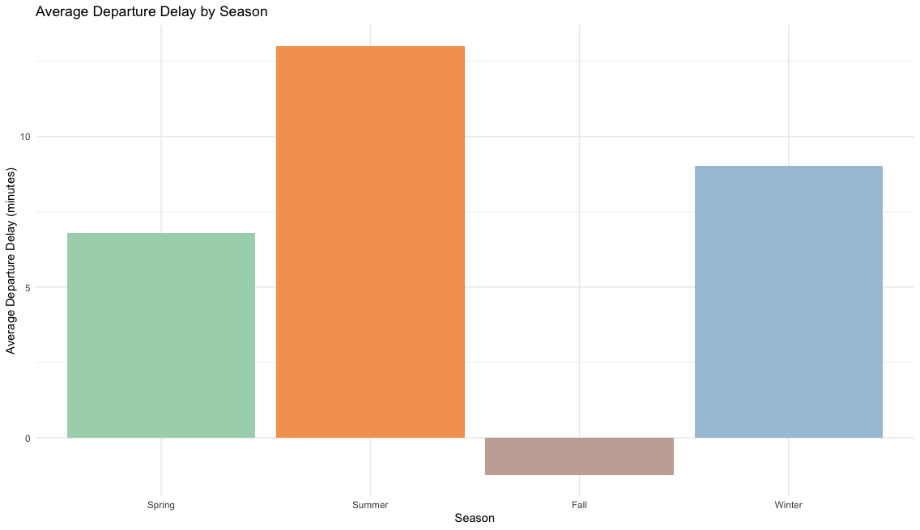
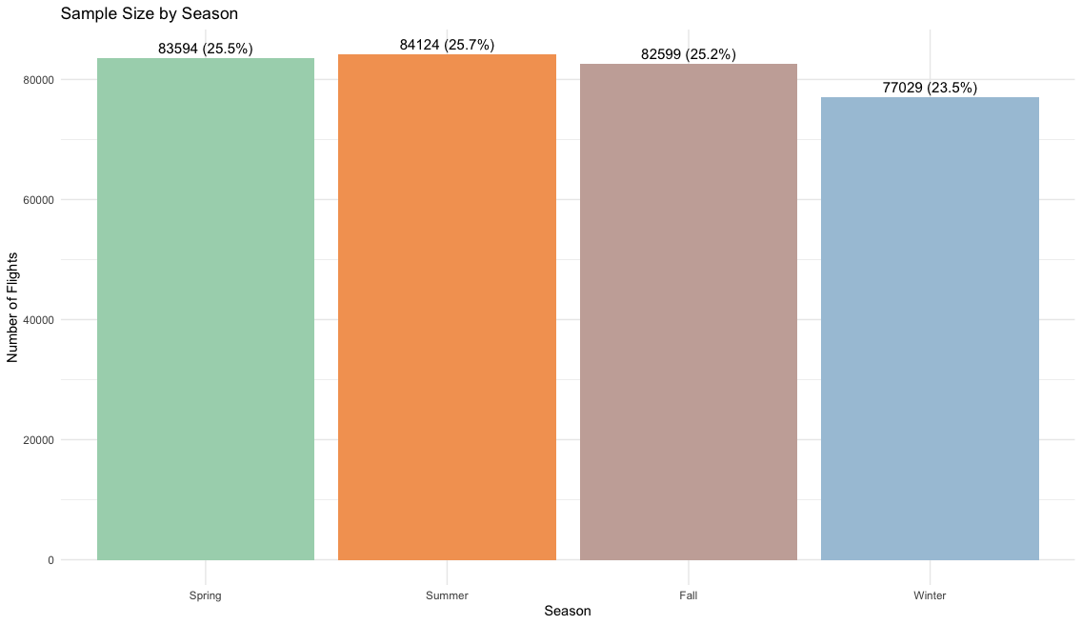
# 9. How do delays vary across distance, a numerical variable?
To examine how delays vary with flight distance, we plot arrival delay against distance and fit a linear trend line. The scatter plot shows no clear relationship between distance and arrival delay. The data points are widely dispersed, and the fitted regression line is nearly flat, indicating a very weak linear association. This suggests that flight distance is not strongly associated with arrival delay. Instead, delays appear to be more strongly associated with other factors, such as departure delay, airport conditions, or time-related variables. In this section, distance is examined as a continuous variable.
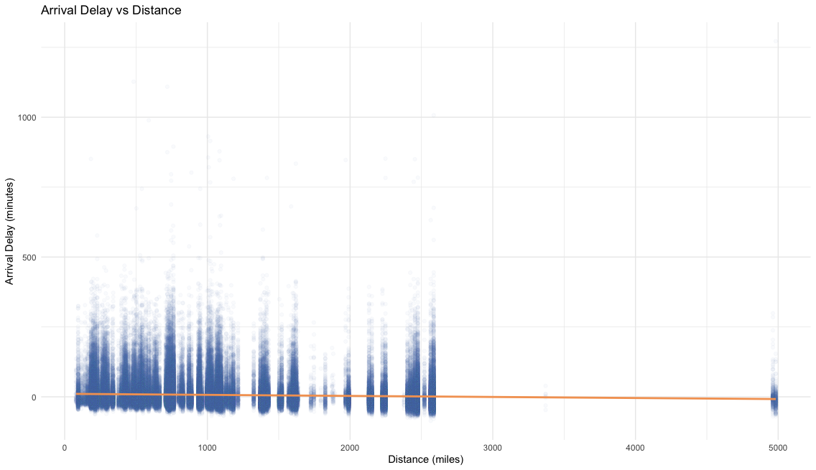
Multivariate Analyses:
# Q10: How does arrival delay vary across airlines and time of day?
From the plot, most airlines generally show an increasing pattern in arrival delay throughout the day, with delays being low in the morning and rising in the afternoon and evening. This is consistent with the univariate analysis, where delays were found to peak around 19:00–21:00.
To ensure that this pattern is not driven by a small subset of airlines, we first examined all 16 carriers in the dataset. The results show that nearly all airlines exhibit a similar increasing trend, with delays reaching their peak between 17:00 and 19:00, followed by a slight decline later in the evening. For clearer visualization, we present a subset of eight representative airlines. Among these, most airlines reach their highest delays during the evening period, while some carriers show slightly earlier peaks. For example, UA peaks around 18:00, while US and EV exhibit peak delays around 17:00–19:00, but still follow the same overall pattern. Although all airlines exhibit this general upward trend, the magnitude of delays differs across carriers, with some airlines (e.g., EV) experiencing much larger increases.
Overall, this suggests that both airline and time of day jointly influence arrival delay, reflecting the accumulation of delays over time.

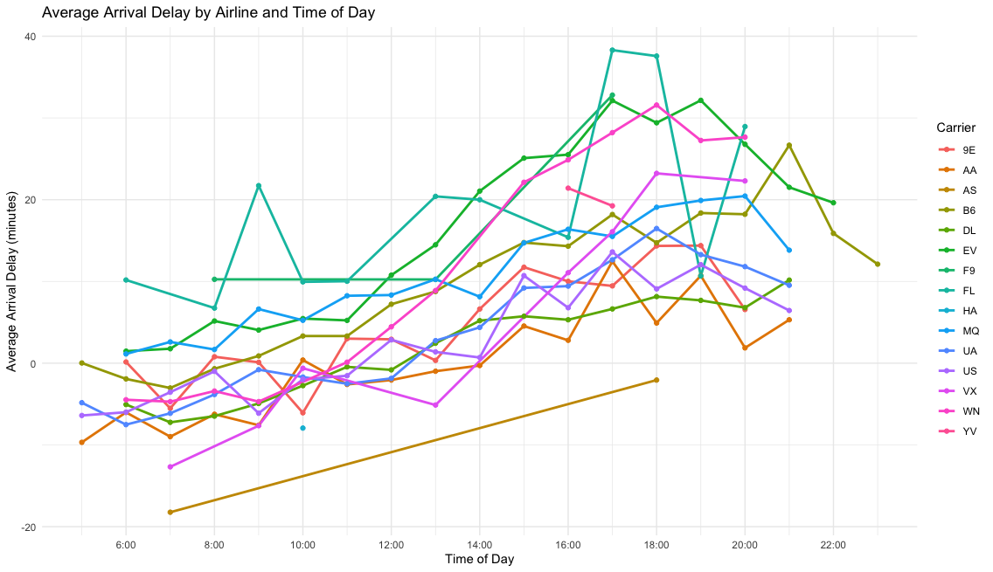
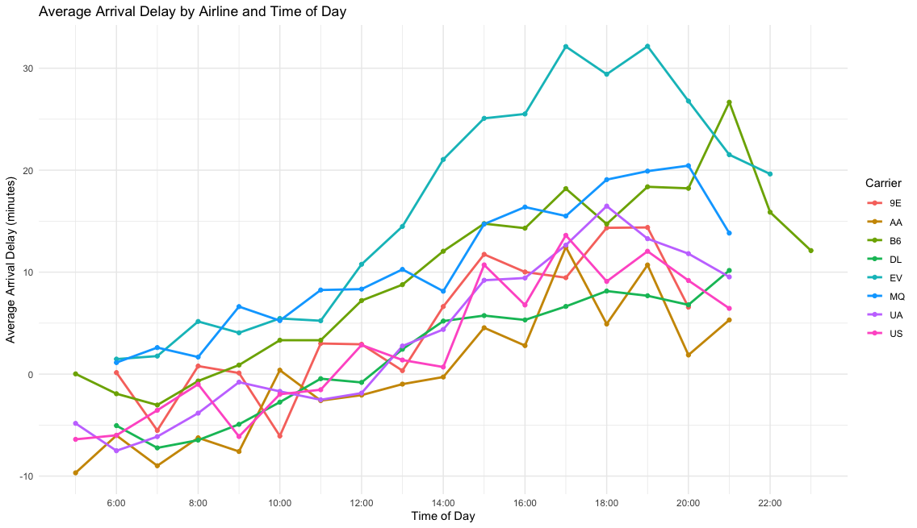
# Q11: How do season and time of day jointly affect arrival delay?
To examine how season and time of day jointly influence arrival delay, flights are grouped by season and hour, and the average arrival delay is computed for each group.
The plot shows that all seasons exhibit a similar time-of-day pattern. Arrival delays are relatively low in the early morning and increase steadily throughout the day, reaching higher levels in the afternoon and evening. This indicates a clear accumulation of delays over the course of the day.
However, there are substantial differences in the magnitude of delays across seasons. Summer exhibits the highest arrival delays, increasing sharply in the afternoon and reaching a peak of approximately 30 minutes in the evening. In contrast, Fall shows the lowest delays, remaining close to zero or even negative for much of the day, indicating that flights are generally more on time or arrive early during this season.
Spring and Winter display similar patterns, with delays gradually increasing throughout the day and peaking in the evening. Their delay levels fall between those of Summer and Fall.
Overall, the results suggest that time of day determines the overall pattern of delays, while season influences the magnitude, indicating a joint effect of temporal and seasonal factors on arrival delay.
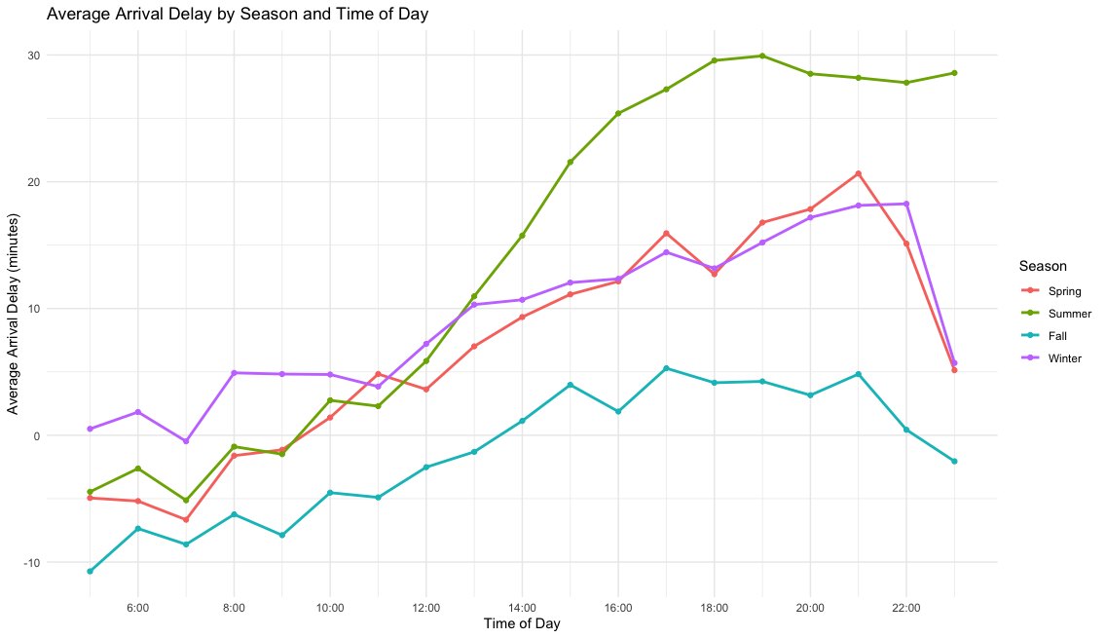
Correlation Analysis
Q13.Which numerical variables exhibit strong correlations, and how might these relationships help explain flight delays?
Based on the correlation heatmap, departure delay and arrival delay exhibit a strong positive correlation, indicating that delays at departure tend to carry over to arrival. Time-related variables—including departure time, scheduled departure time, arrival time, scheduled arrival time, and hour—also exhibit strong correlations with each other. These correlations primarily reflect their shared representation of similar temporal information, rather than meaningful relationships with delay behavior. In addition, air time and distance show a strong positive correlation, which is consistent with the expectation that longer flights require more travel time. Other variables, such as month, day, and minute, show weak correlations with delay variables, suggesting limited linear relationships and lower explanatory power.
Overall, these results highlight departure delay as a key variable associated with arrival delay, while also indicating potential redundancy among time-related variables.
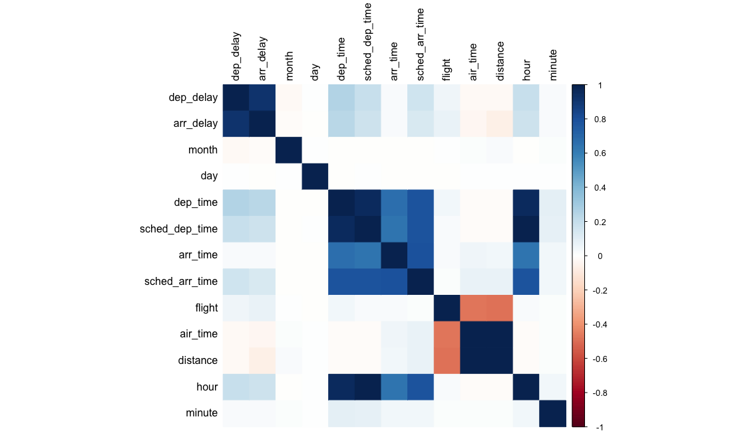

Regression Analyses
Linear regression is a great tool we can use to analyze the relationship between different factors and delays in flights, as well as predict delays based on varying parameters. First, we analyzed a simple linear regression model (shown graphically below), where we examined the relationship between arrival delays and departure delays. We ended with an intercept of -5.8994935, and the slope for our departure delay term was 1.0190929. We can interpret these values as such: when there is no departure delay, a flight is expected to arrive 5.899 minutes early, as negative values for this variable represent early arrivals. For our slope term, we conclude that for every minute the flight is delayed in departure, the arrival delay increases by 1.019 minutes, on average. This model produced positive results, with an adjusted r-squared value of 0.8369, where we can conclude that 83.69% of the variability is explained by our model.
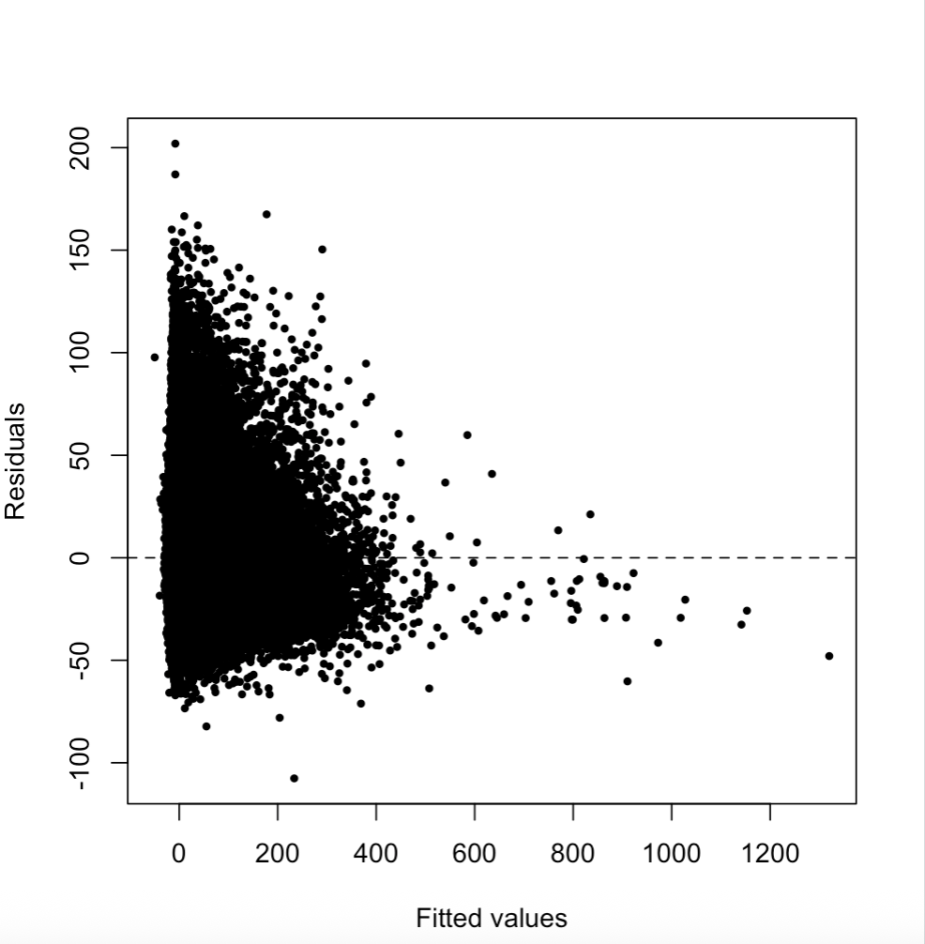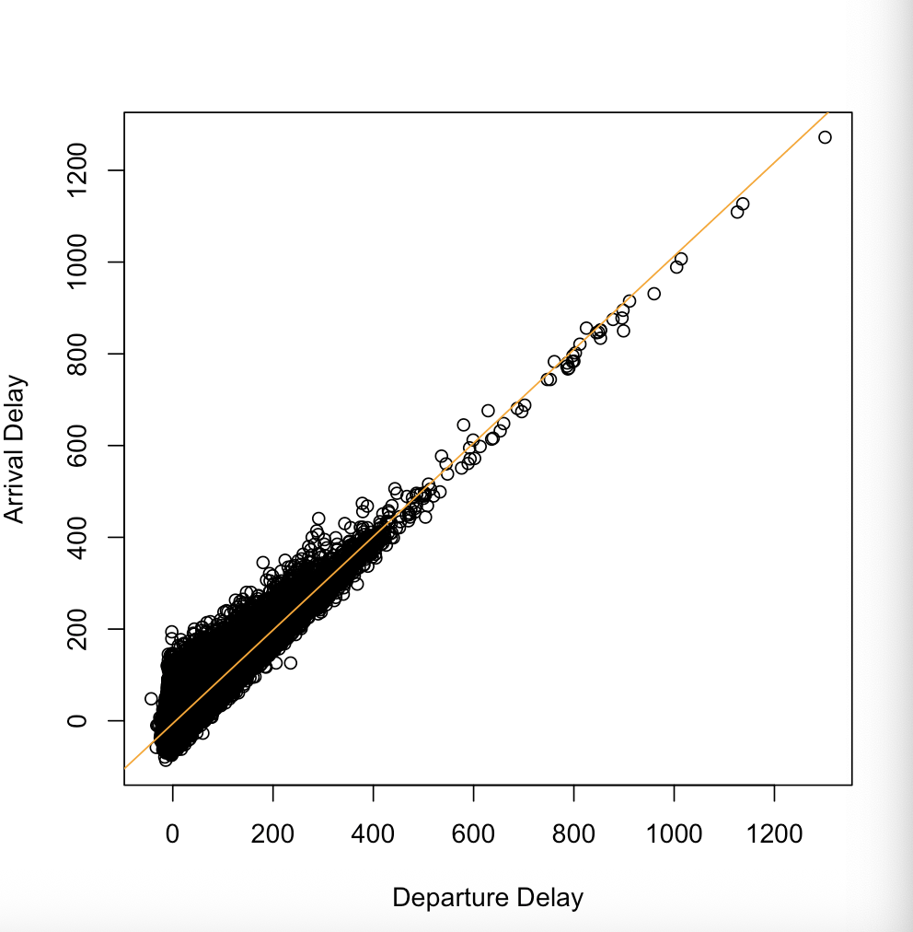
This makes sense, since as we explored above, arrival and departure delay are highly correlated variables. We can examine the plot of residuals vs. fitted values, in the plot above. We see that the majority of the fitted values lie between 0 and 400. The residuals are variable between these values, but after 400, the residuals tend to lie below zero. To remedy this, we attempted to transform the data using square roots, or polynomial regression. The results from this were similar to that of the simple linear regression, with very similar r-squared values. This could be due to the fact that we have less observations with high arrival delays.
Next, we aimed to create a multiple linear regression model to estimate arrival delays with additional parameters. We examined three varying multiple regression models, with an increasing number of parameters. The best performing model to estimate arrival delay, given our observed data, is with the parameters: distance, departure delay, carrier, destination, scheduled departure time, and month. These parameters all proved statistically significant, as they all could play a role in whether a flight arrives on time or not. Shorter flights are more often delayed to accommodate long-haul flights, if a flight departs late it is more likely to arrive later, certain carriers may be more susceptible to delays, busier airports can experience more arrival delays, flights during peak hours, and months with variable weather patterns can experience more delays.
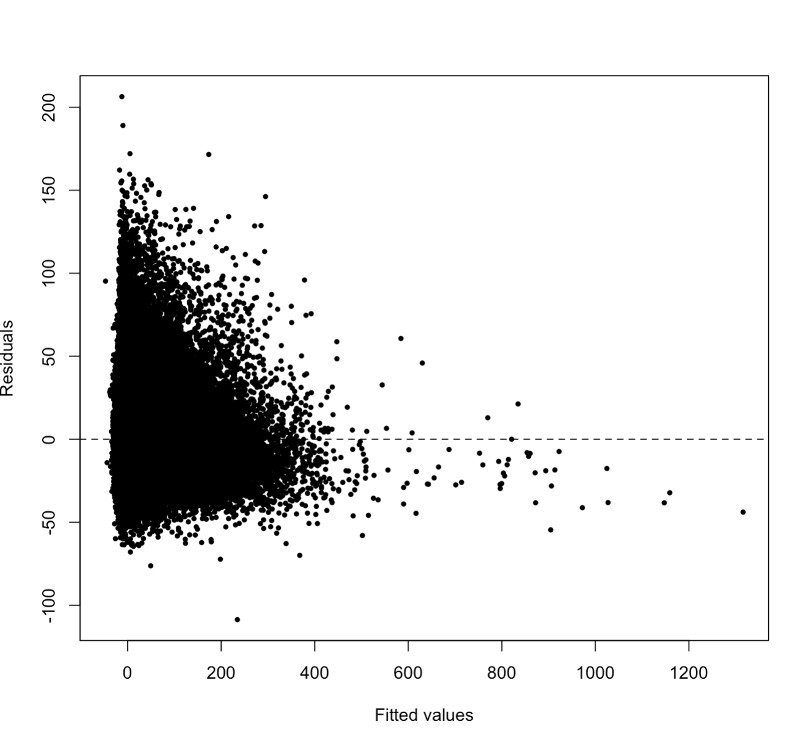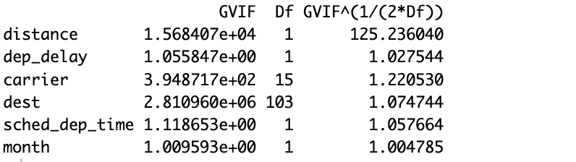
Above, we have a plot of the residuals vs. fitted values from our multiple linear regression model. We can see in the plot that it looks very similar to the one from the simple linear regression model. The bulk of the fitted values are between 0 and 400, with some fitted values lying outside this range. The majority of the variability is towards the left-hand side of the graph. We also tested the colinearity of this model, with the results shown above. We find that the distance parameter had a high VIF (Variance Inflation Factor) compared to the other parameters, with a VIF of 125, which is flagged as problematic. Our model produced an adjusted r-squared value of 0.8434, which is very close to the r-squared value of the simple linear regression model. We can conclude from this finding that adding in the additional parameters to the regression model did not necessarily improve the results of the model much more.
Finally, we focus our attention on a logistic regression analysis of the data. We are going to do a Chi-Squared test on three separate logistic regression models: the null model, a simple logistic model, and a saturated model. We first need to transform our arrival delay data to binary, and we do so by assigning values 1 to those flights that arrived with a delay, and 0 to those who arrived on time or early, to do this we used the if else function on R to add a new column to our flights data set. We then create our three models, starting with the null model, which is just 1, using the glm() function in R with a binomial/logit family. Our simple model consisted of the binary arrival delay column by the departure delay column. Finally, our more saturated model has the same parameters as the multiple linear regression model: departure delay, distance, carrier, destination, scheduled departure time, and month. We then used the anova function on R to compare each model to the other using the Chi-Squared Test. What we found was that the saturated logistic regression model is the preferred model compared to the null and simple logistic models.
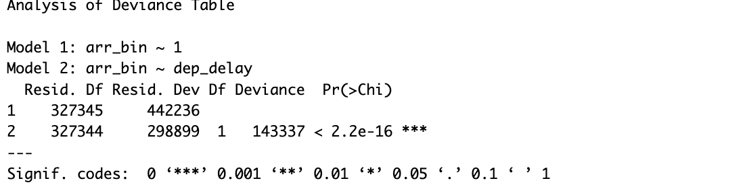
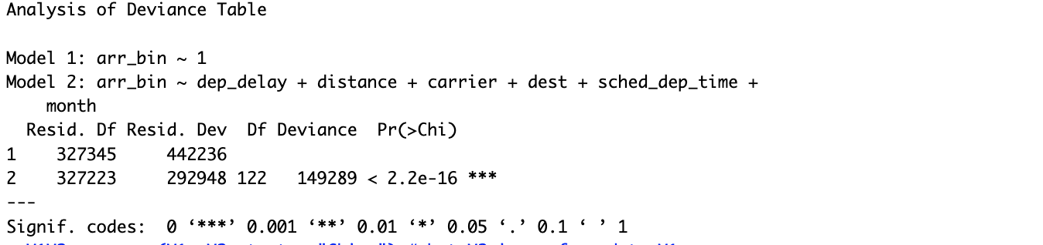
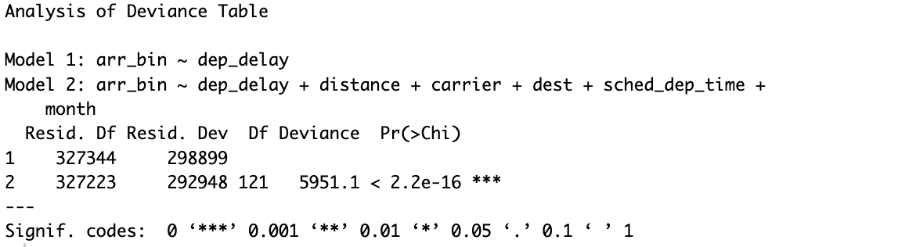
Above, we have the results from the three Chi-Squared tests on the logistic regression models. As we can see, we get a very low p-value for all three tests, leading us to reject the null hypothesis for each test. The first test had the null model as the null hypothesis and the simple model for the alternative hypothesis. With the p-value 2.2e-16 being below the threshold of 0.05, we reject the null model and conclude that the simple logistic regression model is a better fit for our data. We do this for the other two tests, with the more saturated model being the best fit out of the three models. We check this again by comparing the AIC for the three models. The null model produced an AIC of 442238.2, simple model was 298902.8, and the saturated model produced an AIC of 293193.7. Since we are trying to minimize the AIC, we conclude that the saturated logistic model best represents our data.

Principal Component Analyses
For Principal Component Analysis (PCA), the following variables were used from the ‘flights’ dataset of ‘nycflights13’: ‘dep_delay’, ‘arr_delay’, ‘air_time’, and ‘distance’. These continuous variables were chosen because of the expected relationships based on the plot of paired data showing redundancy of departure delay(in minutes) and arrival delay(in minutes), as well as the air time(in minutes) and distance(in miles). By using PCA, these variables can potentially be reduced to a more manageable number of dimensions.

Plot of Paired Data
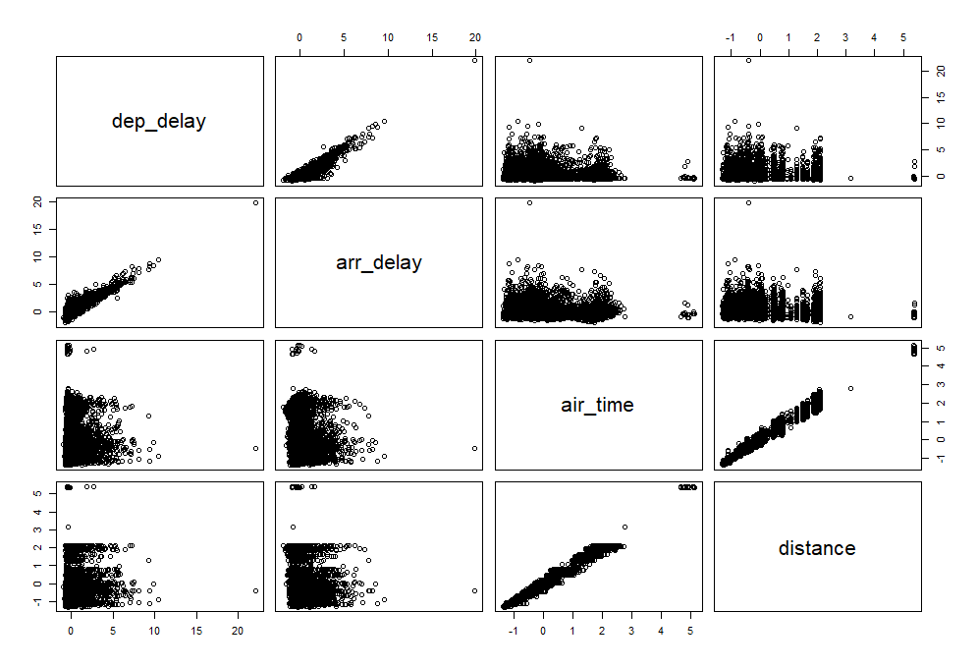
Before deciding to do any normalization, R code was used to apply functions that took the mean and variance of the columns yielding the following table. Based on the values derived using R, the difference of means and variances from each other gave motivation for scaling the data.

Mean and Variance Table of Variables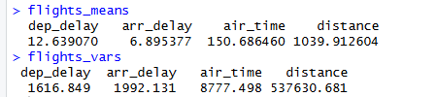
After scaling the data, the following eigenvalues and standardized eigen matrix R was derived. In addition, a scree plot was made using the eigenvalues that were standardized to describe the proportion of variance explained (PVE).
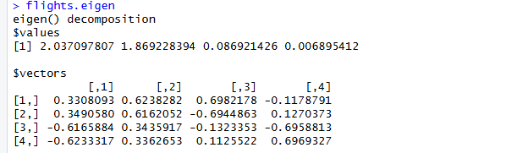
Proportion of Variance Explained Scree Plot and Cumulative Scree Plot
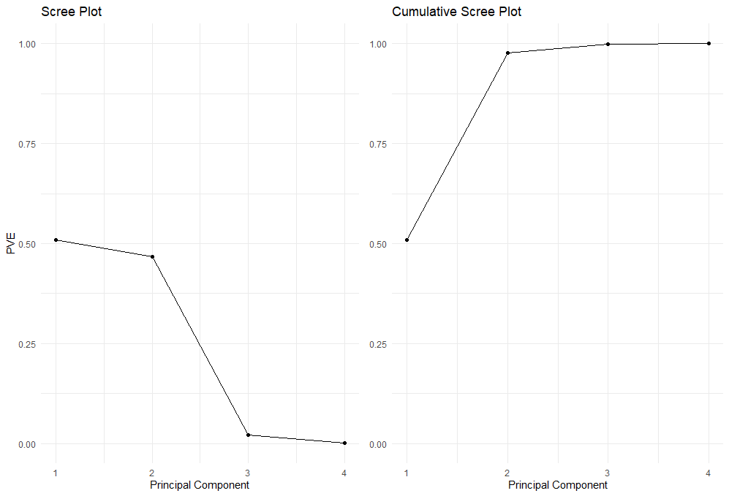

PVE
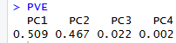
Using the Kaiser rule, including only principal components with eigenvalues greater than one, only two principal components were retained. In addition, the scree plot indicates that the first two principal components cover the majority of the PVE with roughly 51% of PVE by the first principal component and roughly 47% of PVE by the second principal component. This would indicate that roughly 98% of PVE can be explained by the first two principal components which is well above 80% of PVE. Therefore, the first and second principal components are enough to explain the variability by both the standards of the Kaiser rule and scree plot.
Now analyzing the first two principal components using the table below of loadings. The first principal component has the highest negative loading magnitudes for air time and distance meaning with near identical values of approximately 0.617 and 0.6233, and for departure delay and arrival delay the positive loading magnitudes of 0.331 and 0.349 respectively indicate weak effect compared to the air time and distance in the first principal component, so the first component roughly corresponds to a measure of space-time scale of flight. The second principal component has the positive highest magnitude for departure delay and arrival delay at roughly 0.624 and 0.616 respectively, and for the positive magnitudes of air time and distance the magnitudes are roughly 0.336, so the second component roughly corresponds to a measure of delays. So PC1 represents the space-time scale of flight and PC2 represents overall delays.
Loadings of the First two Principal Components
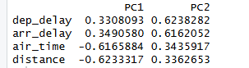
Overall, PCA effectively reduced the total number of dimensions from four to two using the standards of the Kaiser rule and scree plot. By doing so, air time and distance were condensed into the first principal component as a rough measure of duration of flight distance, and departure delay and arrival delay were condensed to the second component as the measure of overall delays. Moreover, roughly 98% of the PVE was preserved which is more than ideal to conclude the successfulness of the analysis. In conclusion, by using PCA, we effectively simplified the four variables of departure delay, arrival delay, air time, and distance to two components of duration of flight distance and overall delays.
Clustering
Before doing any analysis on clustering, we must assess cluster tendencies to see whether or not clustering is a valid analysis to be done on the data. To do that, we will be taking a sample of 500 clean and standardized observations for the purpose of computer computation and graphics. Among those observations each column will be for the following variables: ‘dep_delay’, ‘arr_delay’, ‘air_time’, and ‘distance’.
First, we will look at the Hopkins statistic using the “hopkins” library in R, where according to the documentation for the ‘hopkins’ library a value close to one would mean a high cluster tendency. The Hopkins statistic was approximately 0.99 consistently with various values from the observed sample which meant there is high cluster tendency. Following the Hopkins statistic, VAT was performed to compare “flights” data versus random uniform(0,1) data displaying hard to see any real clustering, but with such a high Hopkins statistic, it would be fair to continue with the clustering analysis.
Heat Maps Flights Data vs Random Data
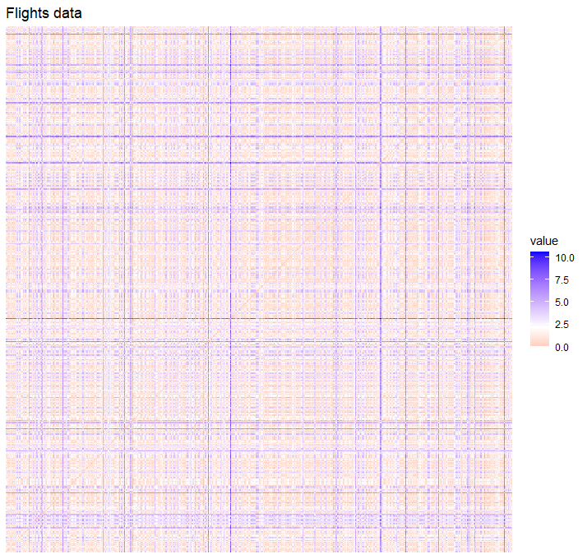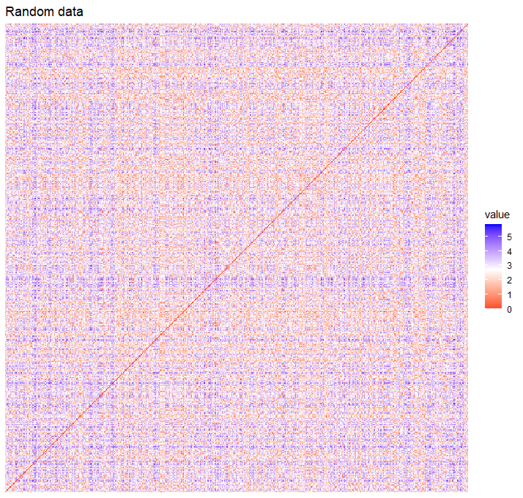

Since the Hopkins statistic indicated that there are clusters within our data, the methods that will be used for cluster analysis are agglomerative for hierarchical clustering and the non-hierarchical clustering methods K-means and K-medoids on the observations of the following variables from the ‘flights’ dataset of ‘nycflights13’: ‘dep_delay’, ‘arr_delay’, ‘air_time’, and ‘distance’.
Now to select the number of clusters, the method that will be used is the average silhouette method. In the average silhouette method, there is conflict with K-medoids displaying two as the number of clusters, but there is consensus that there should be three clusters according to the K-means and agglomerative. Therefore, the chosen number of clusters for this analysis will be three.
Average Silhouettes of Clustering Methods
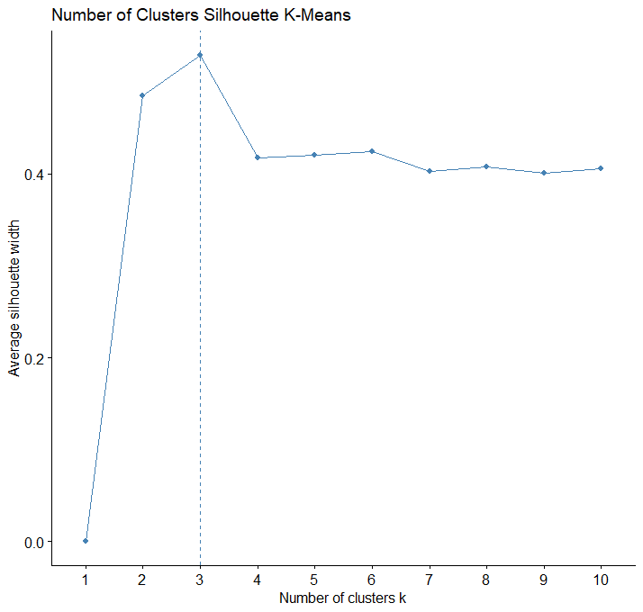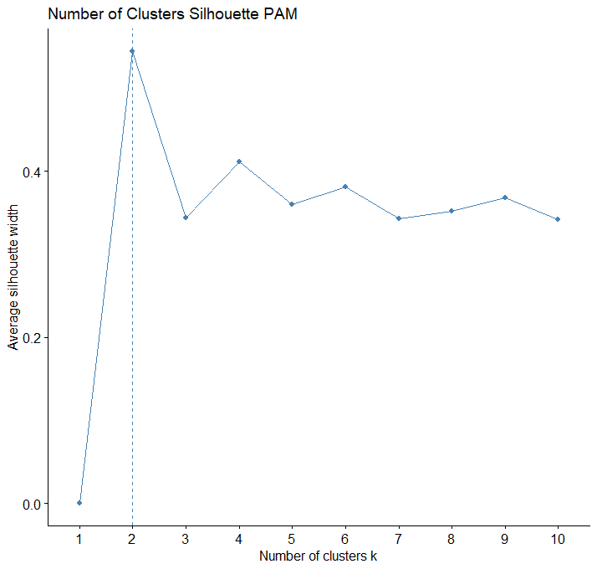
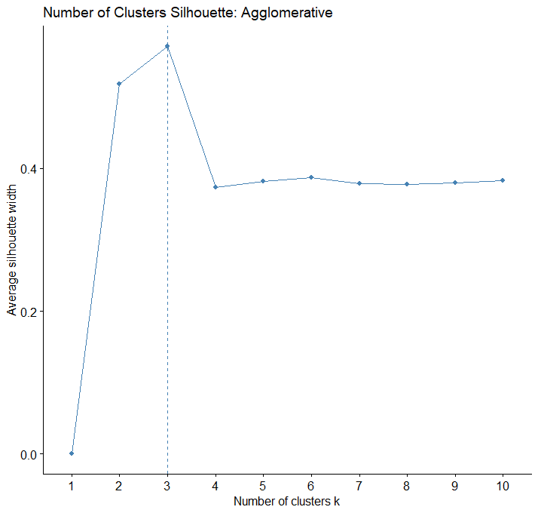
First, agglomerative clustering, the method to calculate distance was euclidean distance and the linkage used was average linkage. Giving the following plot of variables colored using the agglomerative method and a projection of clusters on a 2D plane. In the plot, it is evidence that three clusters was an effective number to encapture the data. We can see that agglomerative clustering is effective in distinguishing space-time scale of flights where yellow represents long flights and short delays, blue represents long flights and long delays, and orange represents short flights and long delays.
Projection of Agglomerative Method Clusters on a 2D Plane
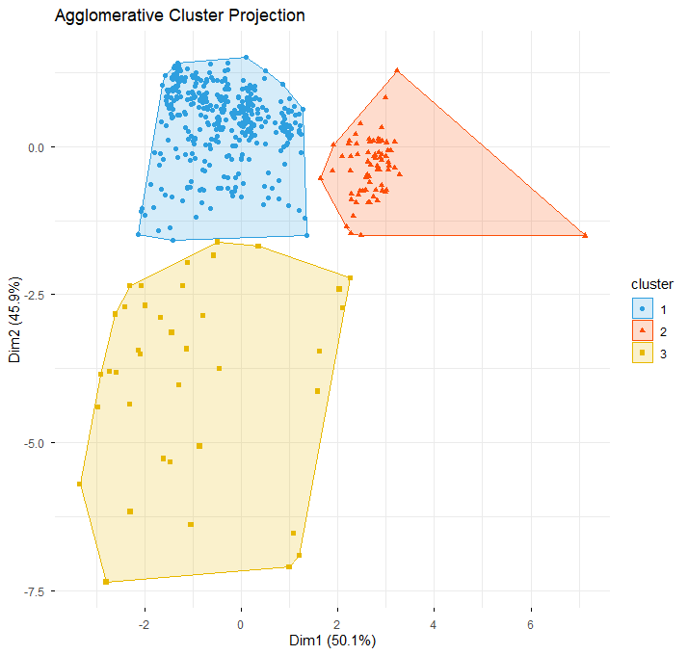

To understand the K-means clusters, paired plots of the variables were made as shown in the following. In the paired plots, it showed the orange cluster’s characteristics: centered departure delay, small arrival delay, large air time, and large distance. The blue cluster’s characteristics: small departure delay, centered arrival delay, small air time, and small distance. The yellow cluster’s characteristics: large departure delay, large arrival delay, varied air time, and varied distance.

Paired Plots of Variables Colored using Agglomerative Method
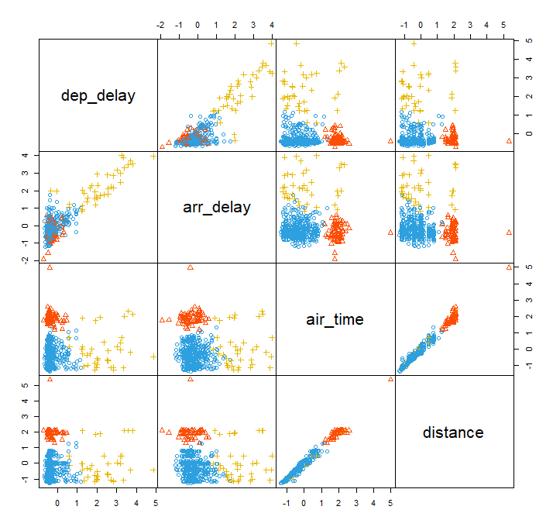
Second, clustering using K-means, where the number of clusters, K, is equal to three.
Proceeding, the following tables and plots were derived using R.
Centers of Clusters Using K-means
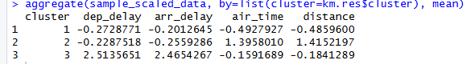
K-Means Cluster Sizes


After running the K-means algorithm the following clusters were made. We can see that K-means clustering is effective in distinguishing space-time scale of flights where yellow represents long flights and short delays, blue represents long flights and long delays, and orange represents short flights and long delays.
K-means Clustering with Geometric Circle
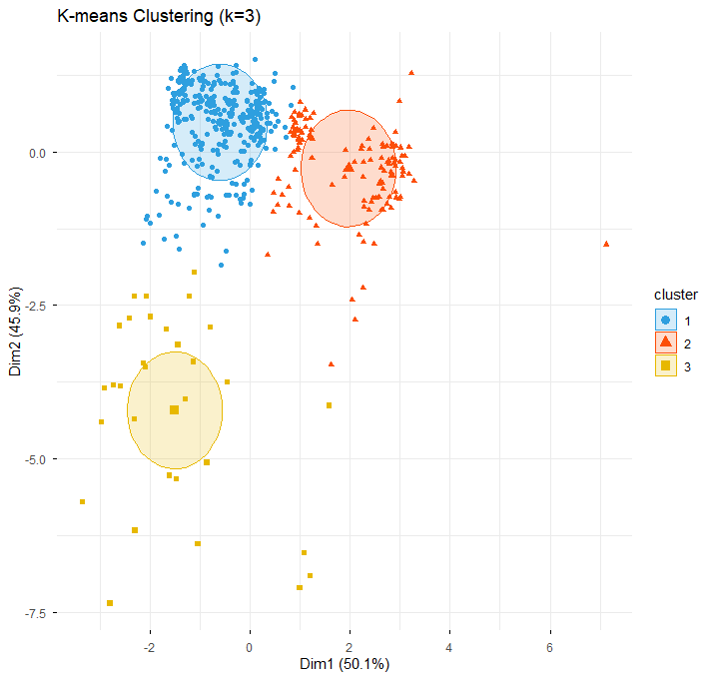
K-means Clustering General Shape no Geometric Circle
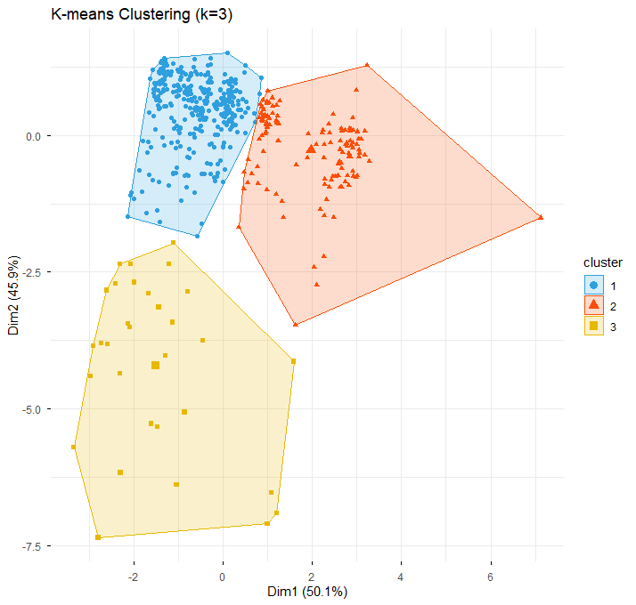

K-means Clustering Pair Plot
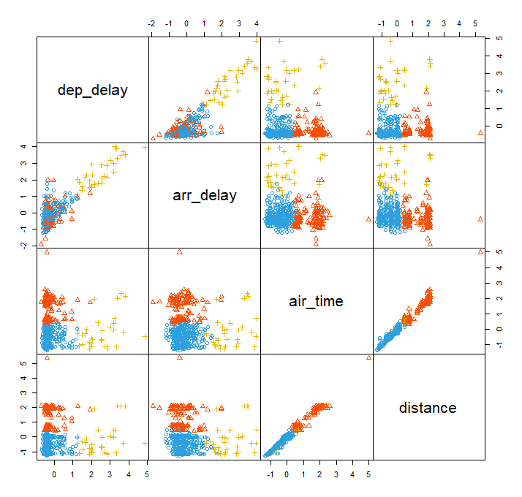
From looking at the clusters, in the paired plots, it showed the orange cluster’s characteristics: varied departure delay, centered arrival delay, large air time, and large distance. The blue cluster’s characteristics: small departure delay, small arrival delay, small air time, and small distance. The yellow cluster’s characteristics: large departure delay, large arrival delay, small air time, and small distance. We can see that agglomerative clustering is effective in distinguishing space-time scale of flights where in both yellow represents long flights and short delays, blue represents long flights and long delays, and orange represents short flights and long delays.
Third, the K-medoids using Partitioning Around the Medoid (PAM), where the number of cluster K, is equal to three The following tables and plots were derived using R.
Cluster Medoids
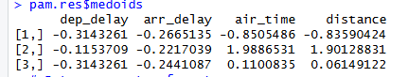
Cluster Sizes
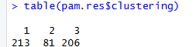

From looking at the K-medoids clusters, K-medoids can only differentiate the length of a flight(scale-time scale of flight).
K-medoids Cluster with Ellipse Shape
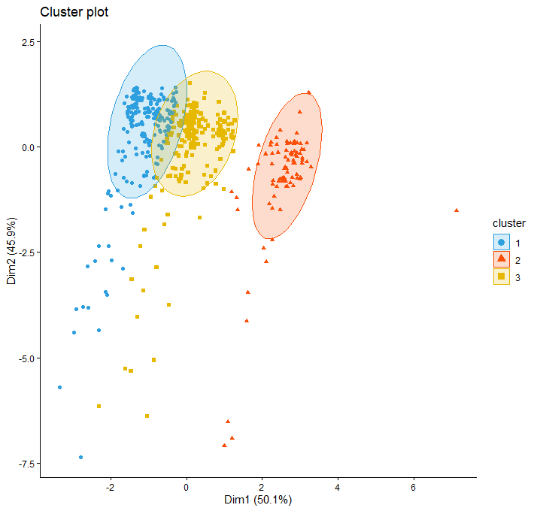
K-Medoids Cluster no Ellipse
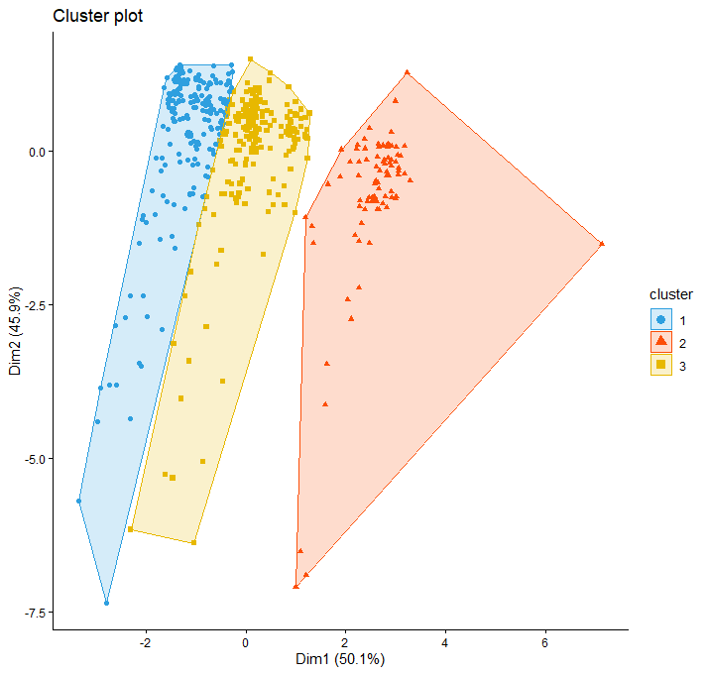
To understand the K-medoids clusters further, paired plots of the variables were made as shown in the following. In the paired plots, it showed the orange cluster’s characteristics: small departure delay, varied arrival delay, large air time, and large distance. The blue cluster’s characteristics: small departure delay, centered arrival delay, small air time, and small distance. The yellow cluster’s characteristics: large departure delay, large arrival delay, varied air time, and varied distance. This confirms that K-medoids can only differentiate by space-time scale of flight.
K-Medoids Pair Plots

Comparing Clusters

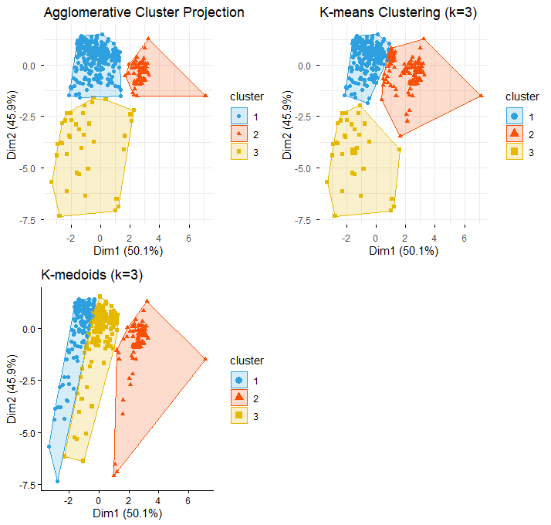
In conclusion, by comparing the clusters, we can see that agglomerative clustering and K-means clustering are effective in distinguishing space-time scale of flights where in both yellow represents long flights and short delays, blue represents long flights and long delays, and orange represents short flights and long delays. In comparison, K-medoids can only differentiate the length of a flight. In terms of usability, agglomerative clustering and K-means yield the most useful information as it distinguishes both space-time scale of flights and general delays.

